**A Turkish Delight**

I have always enjoyed writing and story telling, as many of my friends will attest. I have written a number of articles lately, having completely retired and have posted some on my personal homepage William J Anhorn QC. My venture into genealogy has resulted in some interesting results, not the least of which is establishing a family connection to royalty, all of which I have documented on the website.

My own life experience has also resulted in some interesting and at times amusing stories and antidotes, which for no other specific reason or purpose, I have decided to document for posterity. The first article along this line is entitled, “Find the Time and Have the Courage to Change and Develop a Plan for the Future”. It is in retrospect, an amusing story regarding my own “life-altering event”, but with a not so subtle message.

Now I know what you are thinking, “since golf season is over he has far too much time on his hands”. But I considerate it therapeutic, a form of occupational therapy!

Here is another story, which you will hopefully find of interest.

In 2015, my wife and I, along with two other couples embarked on a European holiday and Mediterranean cruise.

We were travelling abroad on our Canadian passports as follows:

William John Anhorn Passport # GL448XXX

Joan Elaine Anhorn Passport # GL448XXX

We left Canada on August 22nd arriving in Venice, Italy on August 23rd 2015. We spent 4 days in Venice and then boarded the ‘Riviera’ for a 10-day cruise with Oceania Cruises with our final destination or port being Istanbul, Turkey. We had been advised by Oceania prior to leaving that a Turkish visa would be required in order to enter the country. As noted, we were travelling with two other couples from Canada. We were advised that we could obtain the Turkish visa through Oceania or go on-line using the official Turkish government website. One of the couples chose to use Oceania to obtain the visa and the other couple went on-line and had no difficulty in obtaining their visa within a few minutes of completing the application.

We were provided the website address and choose to apply on-line. Upon completing the application and providing the requisite information including credit card information, we were advised that the application was in process and that it may take up to 24 hours to complete. I became concerned as our friend’s application only took a few minutes to be completed before the visas were issued. Concerned that I may have inadvertently been directed to a fraudulent website, I contacted our credit card company and expressed my concern. The credit card provider indicated that the payment was in process and that there was nothing that could be done and that if there was an issue “it had been noted” and to contact them further, if there was a problem. However, the next day we received the Turkish visas and everything appeared to be in order.

Upon boarding the Riviera in Venice, we were instructed to deposit our passports and Turkish visas with the cruise line. These documents were returned just before our departure from the ship on September 7th 2015. We had a tremendous experience on the cruise seeing may different ports of call and enjoying excellent accommodation and cuisine on board ship.

We disembarked from the cruise ship on September 7th at 7:30 am and proceeded to the Turkish passport control area, where my wife and I presented our passports and visas. I hasten to add that my wife handed both the visa and passports, even though they had ONLY asked for our passports. The Turkish passport control officer looked at the visas and then called another officer over and, much to our chagrin, they scrutinized our visas, glancing back at us menacingly from time to time. It was obvious from their demeanor, that there was an issue with the visas. Needless to say, the palms of my hands became sweaty and we both became extremely concerned and nervous. Visions of the movie, “the Orient Express” came to mind. We were asked to step out of the line, in Arabic. (I think)

We were then escorted to another area and a more senior official, who spoke some English studied our documents very carefully and then informed us that the visas that had been presented were fraudulent and that we would have to purchase another visa. In the meantime, our friends proceeded through passport control area without any problem. We together were supposed to meet our Turkish guide outside the facility and board a van for a full day tour of the City of Istanbul, which was the start of our adventure in Turkey.

Not wanting to be delayed or put up any argument, we paid the official $70 US each and he proceeded to apply a “stamp” to our passport. When I asked, “If everything was OK” and if we were free to join our friends, he said, “yes, but first these gentleman would like to speak to you”. We turned around and much to our surprise, two burly Turkish police officers in full uniform were standing there. One of the police officers gestured that we were to accompany them to their office and the passport control official in “broken” English indicated that they wanted to take a statement from us. The hair on the back of my neck stood on end and Joan’s look, as they say in the MasterCard commercial was ”priceless”. It was obvious to us that neither of two officers spoke any English. We reluctantly agreed to accompany them, as though we had any choice! Another passport control supervisor said he would come along and act as an interpreter and he indicated that we had no choice but to comply. My “lawyer” instinct suddenly kicked in and I started to question their authority. Joan, in not too subtle terms grabbed my arm and told me, to “shut the F….up!” This message I understood clearly and it did not require any interpretation! She better than I recognized that we were at a distinct disadvantage and that it was best to co-operate with the Turkish authorities. What a delight!

We were told that the visa was fraudulent and that we were under suspicion of falsifying the travel document. The officer, through the interpreter, demanded that we produce evidence that we paid for the visa after having explained that we had purchased the visa on-line from the official Turkish website. We were provided access to a computer and my wife after much difficulty was able to access our email account and retrieve the receipt that had been issued. I should point out that she had difficulty, at first blush, in accessing the email account and beads of perspiration rolled down her forehead. She tried several times to enter our password, but each time the computer indicated that it was the “wrong password” as the police officers looked on with suspicion. Finally, she was able to gain access. I later learned that she had difficulty because the keyboard was in “Turkish”!

I again explained that we had obtained the visa from the official Turkish website, which statement was met with much skepticism and disbelief. Since I had obtained the visa online from a website, I was then shown a number of different websites that supposedly had been used to issue fraudulent visas. None of them resembled the one that I had used and again, I was insistent that the website was the official Turkish website.

On the next page is a copy of the official Visa received from the Turkish Tourism office. It looks pretty official to me. But then again, what do I know!



Note that the “nationality” section has been left blank.

In the meantime, after more than an hour, our friends were still waiting for us outside the terminal. I asked that I be allowed to go out and explain the situation and was advised that I could only go under police escort! I met our friends and our Turkish guide and the guide was advised by the police officer of the circumstances. Being uncertain as to how much time it would take to clear things up, I suggested that they proceed with the planned tour for the day and that we would take a taxi to the hotel. Our tour guide was quite insistent that we do not do that and indicated that they would tour the city for an hour and come back to get us. She was quite adamant after she spoke to the police officer, which only heightened my anxiety.

Upon returning to the police office, we were advised by the passport control supervisor and interpreter that the police had examined the visa in greater detail based upon our insistence that it had been issued by the official government website. In fact, it had been determined that the visas had been issued by the appropriate government authority. We were advised that someone **within** the department had altered the application to show that our nationality was “Kuwait” not Canadian. We were advised that residents of Kuwait although requiring a Turkish visa to enter the country are not required to pay a fee. It appeared that the credit card payment had been diverted “offshore” and once the payment processed, then the visa was sent to our email address. This perhaps accounted for the

24 hour delay in processing. We were advised that the visa was authentic, the only difference being that the issued visa left our nationality “blank”, something we had not noticed but which had alerted the passport control officers. We were told that “fake” visas were quite common.

At that point my wife asked the passport control officer who had been acting as the interpreter “Are we still in trouble?” He responded somewhat emphatically, “yes”, which brought her to tears. In retrospect, he may have misunderstood her question.

We were then asked if we wished to file an official complaint. We indicated that we did, as we felt strongly that, the authorities should investigate the matter, as there may be others who unsuspectingly may be subject to this internal government fraudulent scheme. We were then advised that we would have to provide a written statement. A statement was prepared painstakingly by the police officer on a computer as we recited the circumstances. The statement was printed off and handed to each of us and we were asked to sign it. The statements were all in “Turkish”!

At this point again, my “lawyer” instincts kicked in again and I expressed reluctance to sign something that I could not read and did not understand. The interpreter in language, which I clearly understood said, “Do you want to get out of here? If you do, then sign then it, it says exactly what you told him!”

With some legitimate hesitation, and my hands trembling, we both each reluctantly signed our statements.

I am sure my criminal law professor, must have rolled over in his grave!

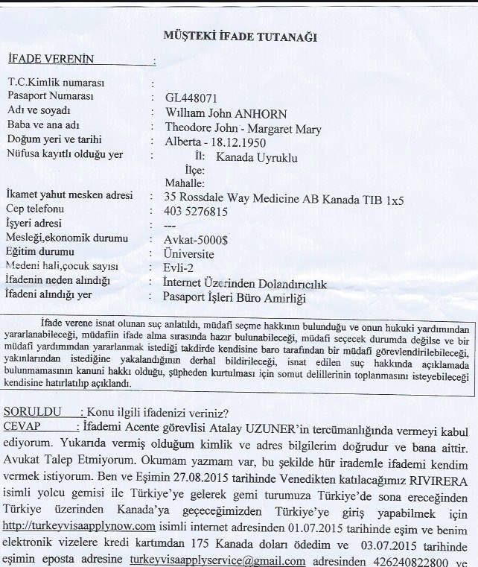

The First Page of My 4 Page Statement to the Turkish Authorities

In the meantime, our tour guide returned she was told that we were not free to go until the “DA” or prosecutor authorized our release. He obviously had seen too many Perry Mason TV shows!

We agonized for what seemed hours as the police officer kept phoning the “DA” but was unable to get through. It was now approaching 12:30 in the afternoon, and we overheard that the “prosecutor” had been in court and may have left early for lunch and might not be back for several hours! The thoughts of spending time in a Turkish jail came to mind.

Our tour guide told us she had to leave to us, as she said she could not wait any longer. She left. Within a few minutes, the police officer advised that he had been able to reach the prosecutor and after explaining the situation to him and after having reviewed our statements, he indicated that we were free to go. Fortunately, we able to txt our friends before they left and we were able to meet up with them but not after spending more than 3 hours in Turkish custody!

As you can quite imagine, this experience was very upsetting and although we can look back on it with some amusement, the reality is that situation at the time was quite serious.

On returning home, we wrote to the Canadian immigration authorities indicating that we felt the circumstance surrounding our ordeal should be brought to their attention and thoroughly investigated by the appropriate authorities. The fact that we paid twice for our Turkish visas was of little concern. What was of concern was that this fraudulent activity should be stopped and those responsible within the Turkish government agency prosecuted, so that others would not fall victim to this scheme.

Needless to say, this complaint fell on deaf ears. A letter to the Turkish embassy had similar results-“Nada!”

We enjoyed the rest of our tour of this ancient country without any further incident.

So ends the story of our frightening experience in Istanbul-a strange but true story but not quite a Turkish delight!

William J Anhorn QC

December 23rd, 2017

Medicine Hat, Alberta